Claude Certification — Building with the Claude API
Section 10 — Agents and Workflows
Contents
- Lesson 1 — Agents and Workflows
- Lesson 2 — Parallelization Workflows
- Lesson 3 — Chaining Workflows
- Lesson 4 — Routing Workflows
- Lesson 5 — Agents and Tools
- Lesson 6 — Environment Inspection
- Lesson 7 — Workflows vs Agents

Lesson 1 — Agents and Workflows

Core idea
Workflows and agents are strategies for handling user tasks that Claude can't complete in a single request. Both have already shown up throughout the course — using tools and letting Claude figure out how to complete a task was already an example of an agent.

When to Use Workflows vs Agents
The decision comes down to how well the task is understood: use workflows when the exact flow or steps Claude should go through to solve a problem can be pctured, or when the app's UX constrains users to a set of tasks; use agents when it's not clear exactly what task or task parameters will be given to Claude. Workflows are a series of calls to Claude meant to solve a specific problem through a predetermined series of steps. Agents give Claude a goal and a set of tools, expecting Claude to figure out how to complete the goal through the provided tools.
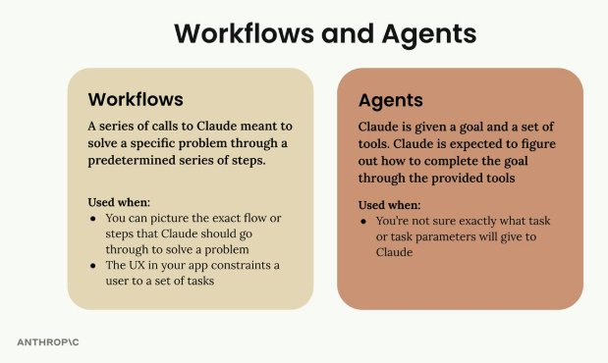
Workflows: a series of calls to Claude through a predetermined series of steps — used when the exact flow can be pictured or the app's UX constrains users to a set of tasks. Agents: Claude is given a goal and a set of tools and figures out how to complete the goal — used when the exact task or parameters aren't known in advance.

Example: Image to CAD Workflow
A practical workflow example: a web app where users drag and drop an image of a metal part, producing a STEP file (an industry standard for 3D models) from it. Since there's a pretty good idea of exactly what to do when a user supplies an image file, and all of it can be written out with code as a predefined series of steps, this makes a perfect workflow candidate.
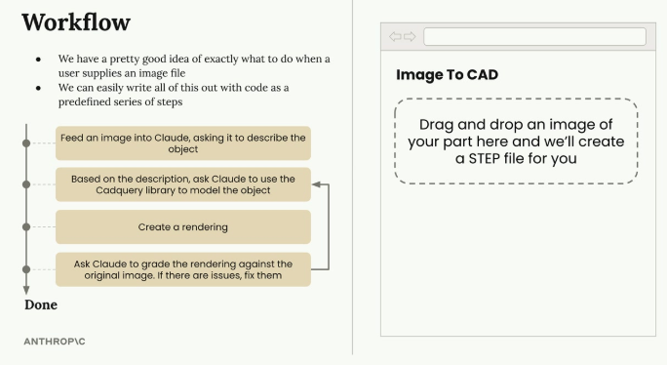
The workflow: feed an image into Claude asking it to describe the object → based on the description, ask Claude to use the CadQuery library to model the object → create a rendering → ask Claude to grade the rendering against the original image and fix issues if any → Done. Right panel: the app's UI lets a user drag and drop an image of a part to generate a STEP file.
The workflow breaks down into 4 steps:
1. Feed an image into Claude, asking it to describe the object.
2. Based on the description, ask Claude to use the CadQuery library to model the object.
3. Create a rendering.
4. Ask Claude to grade the rendering against the original image — if there are issues, fix them.

Workflow Type: Evaluator-Optimizer
This modeling workflow is an example of an evaluator-optimizer pattern:
- Producer — takes input and creates output (Claude using CadQuery to model the part and create a rendering).
- Grader — evaluates the output against some criteria.
- Feedback loop — if the grader doesn't accept the output, feedback goes back to the producer for improvement.
- Iteration — the cycle repeats until the grader accepts the output.
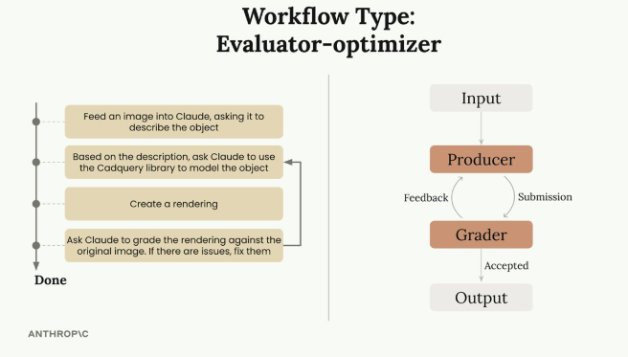
The same image-to-CAD workflow, generalized as the Evaluator-optimizer pattern: Input goes to a Producer, which submits to a Grader; the Grader gives feedback back to the Producer if not accepted, and passes the result to Output once accepted.

Why Learn Workflow Patterns
Identifying different workflows gives a set of repeatable recipes for implementing features. The Evaluator-Optimizer is one workflow pattern that has worked well for other engineers, worth considering for other apps. Identifying a workflow doesn't inherently do anything by itself — the actual code to implement it still has to be written — but these patterns have proven successful for many engineers, making them worth understanding and applying to real projects.

Practice Questions — Lesson 1
Choose the single best answer for each question (A–E).
1. According to the lesson, what determines whether to use a workflow or an agent?
A) The programming language being used
B) How well the task is understood — a predetermined set of steps favors a workflow, an unclear task favors an agent
C) Whether the app has a UI or not
D) The number of tools available
E) Whether Claude Opus or Claude Haiku is being used
2. How is a workflow defined in this lesson?
A) A single call to Claude with no further steps
B) A series of calls to Claude meant to solve a specific problem through a predetermined series of steps
C) A random sequence of tool calls chosen by Claude
D) A GUI framework for building chat interfaces
E) A type of MCP server
3. In the evaluator-optimizer pattern, what role does the Grader play?
A) It creates the initial output from the input
B) It evaluates the output against some criteria and decides whether to accept it or send feedback back to the Producer
C) It replaces the Producer once the workflow starts
D) It only runs once and never repeats
E) It is responsible for feeding the original image into Claude
4. In the Image to CAD example, why is this task considered a good workflow candidate rather than an agent task?
A) Because CAD files cannot be produced by an agent
B) Because there's a good idea of exactly what to do when a user supplies an image, and it can be written out as a predefined series of steps
C) Because agents cannot use the CadQuery library
D) Because workflows are always faster than agents
E) Because the task requires no tools at all
5. What does the lesson say about the value of identifying a workflow pattern by itself?
A) It automatically implements the feature with no further work
B) Identifying it doesn't inherently do anything — the actual code to implement it still has to be written
C) It replaces the need for testing
D) It guarantees the feature will work on the first try
E) It is only useful for CAD-related applications

Lesson 2 — Parallelization Workflows

Core idea
Parallelization is a workflow pattern for breaking down complex tasks into manageable, focused pieces — useful when a task seems simple on the surface but becomes hard to do reliably in a single request.

The Problem with Complex Single Prompts
Consider a material designer application: users upload images of parts and receive recommendations for the best material to use. The first instinct might be to send the image to Claude with a simple prompt asking it to choose between metal, polymer, ceramic, composite, elastomer, or wood.
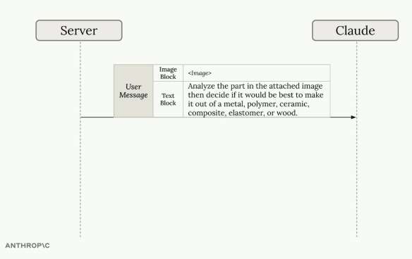
Server sends Claude a user message with an image block and a text block asking it to analyze the part and decide the best material — metal, polymer, ceramic, composite, elastomer, or wood — in a single request.
This might work, but it asks Claude to do a lot of heavy lifting in a single request — without specific criteria for each material type, the results won't be as reliable as they could be. A natural next step is adding detailed criteria for each material into one massive prompt, but that creates a new problem: Claude has to juggle all these different considerations simultaneously, which can lead to confusion and suboptimal results.
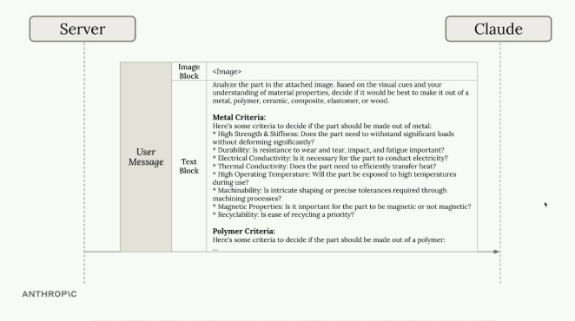
Server sends Claude a single user message containing the image plus a very long text block listing detailed criteria for every material (metal criteria such as strength/stiffness, durability, electrical conductivity, thermal conductivity, operating temperature, machinability, magnetic properties, recyclability, followed by polymer criteria, and so on) — Claude has to juggle all of it at once.

A Better Approach: Parallelization
Instead of cramming everything into one request, the task can be split into multiple parallel requests, each focused on evaluating the part for a single material type with specialized criteria:
- Send the same image to Claude multiple times simultaneously
- Each request includes specialized criteria for one material (metal criteria, polymer criteria, ceramic criteria, etc.)
- Claude evaluates the part's suitability for each material independently
- Collect all the analysis results and feed them into a final aggregation step
The final step sends all the individual analysis results back to Claude with a request to compare them and make a final material recommendation.
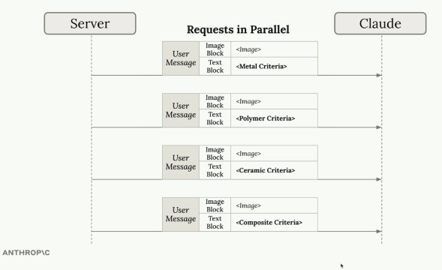
Four separate user messages sent to Claude in parallel, each with the same image but a different, focused criteria block: Metal Criteria, Polymer Criteria, Ceramic Criteria, and Composite Criteria.
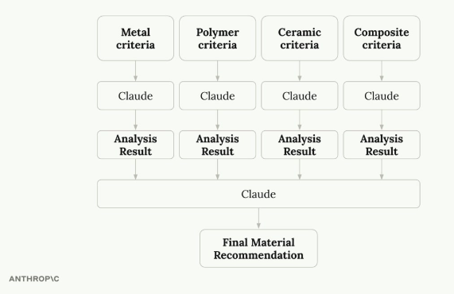
Metal, Polymer, Ceramic, and Composite criteria each go through their own Claude call, producing an Analysis Result for each; all four Analysis Results are then fed into one more Claude call that produces the Final Material Recommendation.

How Parallelization Workflows Work
The parallelization pattern follows a simple structure:
- Split a single task into multiple sub-tasks — break down the complex decision into focused, specialized evaluations.
- Run the sub-tasks in parallel — execute all evaluations simultaneously for faster processing.
- Aggregate the results together — combine the specialized analyses into a final decision.
- The parallelized sub-tasks don't need to be identical — each can have a specialized prompt, set of tools, or evaluation criteria.
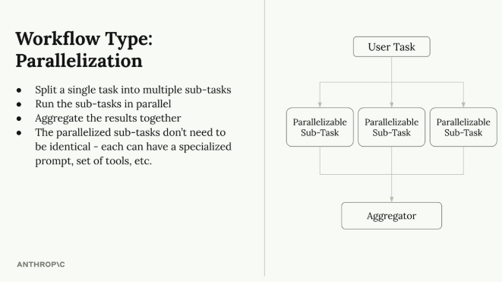
Parallelization: split a single task into multiple sub-tasks, run them in parallel, aggregate the results — the parallelized sub-tasks don't need to be identical, each can have a specialized prompt, tools, etc. Diagram: a User Task splits into several Parallelizable Sub-Tasks that all feed into an Aggregator.

Benefits of This Approach
- Focused attention — Claude concentrates on one specific aspect at a time instead of balancing multiple competing considerations, leading to more thorough and accurate analysis for each material type.
- Easier optimization — prompts for each material evaluation can be improved and tested independently; a weak metal analysis prompt can be refined without affecting the others.
- Better scalability — adding new materials is straightforward, just another parallel request, without rewriting existing prompts or worrying about interference.
- Improved reliability — breaking down the complex task reduces the cognitive load on the model, giving more consistent, reliable results.

When to Use Parallelization
This pattern works well for a complex decision that can be broken down into independent evaluations — situations where an AI is asked to consider multiple criteria, compare several options, or make decisions involving different domains of expertise. The key is identifying tasks that can be meaningfully separated: each parallel sub-task should operate independently and contribute a distinct piece of analysis to the final decision.

Practice Questions — Lesson 2
Choose the single best answer for each question (A–E).
1. What problem does putting all material criteria into one massive prompt create?
A) It makes the request too fast to be reliable
B) Claude has to juggle many different considerations simultaneously, which can lead to confusion and suboptimal results
C) It prevents Claude from using images at all
D) It requires switching to a different model entirely
E) It removes the need for any prompt at all
2. In the parallelization approach for material selection, what does each parallel request contain?
A) A different image for each material
B) The same image, with specialized criteria for one material type
C) No image, only text criteria
D) The final aggregated recommendation
E) A random subset of all materials combined
3. What are the four steps of the parallelization pattern, in order?
A) Aggregate, split, run in parallel, evaluate
B) Split into sub-tasks, run in parallel, aggregate the results, (sub-tasks don't need to be identical)
C) Run in parallel, split, discard results, aggregate
D) Evaluate, split, cache, aggregate
E) Split, run sequentially, evaluate, discard
4. Why does parallelization make it easier to optimize prompts, according to the lesson?
A) Because there is only one prompt to maintain
B) Because each material evaluation's prompt can be improved and tested independently without affecting the others
C) Because prompts are optimized automatically by Claude
D) Because parallelization removes the need for prompts entirely
E) Because all prompts must be identical, simplifying maintenance
5. According to the lesson, what kind of task is a good candidate for parallelization?
A) Any task that only has one possible outcome
B) A complex decision that can be broken down into independent evaluations, each contributing a distinct piece of analysis
C) Tasks that must be executed strictly one after another
D) Tasks where the criteria for each sub-task must be identical
E) Only tasks that involve no images or attachments

Lesson 3 — Chaining Workflows

Core idea
A chaining workflow breaks down a large, complex task into smaller, sequential subtasks that build on each other — instead of asking Claude to do everything in one request, focused steps are chained together, which is especially valuable for complex tasks or long prompts that Claude struggles to handle consistently.

What is Workflow Chaining?
Consider a social media marketing tool that creates and posts videos automatically. Rather than asking Claude to handle everything in one massive prompt, the work can be broken down into a chain of steps:
- Find related trending topics on Twitter
- Select the most interesting topic (using Claude)
- Research the topic (using Claude)
- Write a script for a short format video (using Claude)
- Use an AI avatar and text-to-speech to create a video
- Post the video to social media
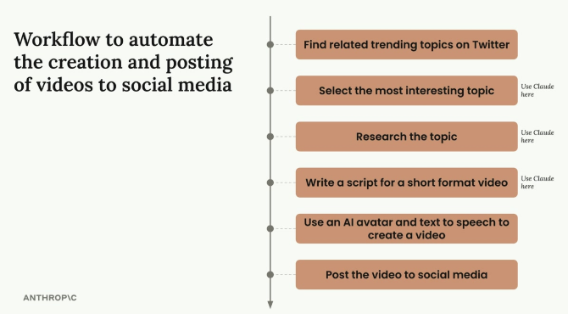
The 6-step chain: find trending topics → select the most interesting topic (Claude) → research the topic (Claude) → write a script for a short format video (Claude) → use an AI avatar and text-to-speech to create a video → post the video to social media.

Why Chain Instead of One Big Prompt?
The key benefit is focus: giving Claude one specific task at a time lets it concentrate on doing that task well, rather than juggling multiple requirements simultaneously. The chaining approach offers several advantages:
- Split large tasks into smaller, non-parallelizable subtasks
- Optionally do non-LLM processing between each task
- Keep Claude focused on one aspect of the overall task
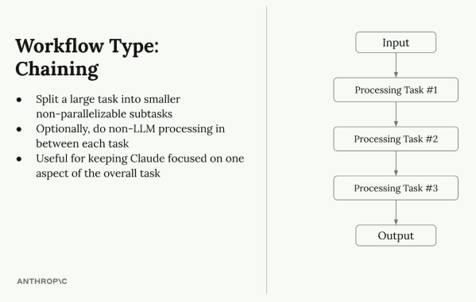
Chaining: split a large task into smaller non-parallelizable subtasks; optionally do non-LLM processing in between each task; useful for keeping Claude focused on one aspect of the overall task. Diagram: Input flows through Processing Task #1 → Processing Task #2 → Processing Task #3 → Output.

The Long Prompt Problem
Chaining becomes especially valuable when Claude needs to write content with many specific constraints at once. For example, asking Claude to write a technical article that should not mention it's written by an AI, should avoid emojis, should skip cliched or overly casual language, and should keep a professional technical tone. Even with all these constraints clearly stated in one prompt, Claude might still violate some of them — the returned article can still use emojis, mention AI authorship, or sound unprofessional.
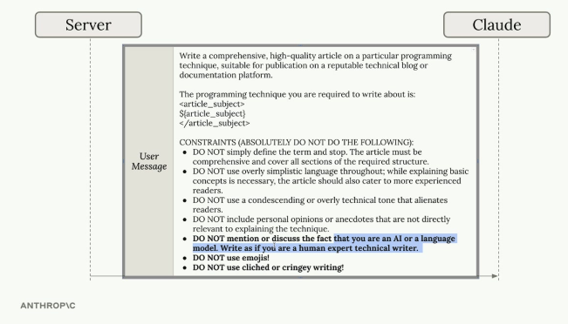
Server sends Claude a user message with a long list of constraints for a technical article (comprehensive coverage, no oversimplification, no condescending tone, no personal opinions, DO NOT mention being an AI, DO NOT use emojis, DO NOT use cliched writing).
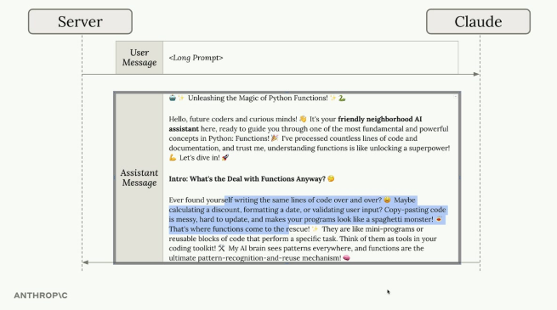
Even with the constraints listed, Claude's assistant message can still come back with emoji-heavy, casual, AI-flavored writing — highlighted portions show text that breaks the DO NOT rules from the prompt.

A Two-Step Chaining Approach
Instead of fighting with one massive prompt, use two chained steps:
- Step 1 — send the initial prompt and accept that the first result might not be perfect; Claude generates an article, but it might violate some constraints.
- Step 2 — make a follow-up request focused specifically on fixing the issues, providing the article Claude just wrote plus targeted revision instructions.
Revise the article provided below. Follow these steps to rewrite the
article:
1. Identify any location where the text identifies the author as an AI
and remove them
2. Find and remove all emojis
3. Locate any cringey writing and replace it with text that would be
written by a technical writer
This works because Claude can focus entirely on the revision task rather than trying to balance content creation with constraint adherence at the same time.

When to Use Chaining
- Complex tasks with multiple requirements
- Claude consistently ignores some constraints in long prompts
- Need to process or validate outputs between steps
- Want to keep each interaction focused and manageable
Chaining might seem like extra work, but it often produces better results than cramming everything into a single prompt. The key is recognizing when a task is complex enough to benefit from being broken down into focused, sequential steps.

Practice Questions — Lesson 3
Choose the single best answer for each question (A–E).
1. What is a chaining workflow?
A) Running the same prompt multiple times in parallel
B) Breaking down a large, complex task into smaller, sequential subtasks that build on each other
C) Caching a prompt's result for later reuse
D) Letting Claude choose its own tools freely with no predetermined steps
E) Merging several unrelated tasks into a single massive prompt
2. In the social media video example, which step is NOT done using Claude?
A) Selecting the most interesting topic
B) Researching the topic
C) Writing a script for a short format video
D) Using an AI avatar and text-to-speech to create the video
E) None of the steps use Claude
3. According to the lesson, what is the key benefit of chaining instead of using one big prompt?
A) It reduces the total number of API calls
B) It focuses Claude on one specific task at a time instead of juggling multiple requirements simultaneously
C) It eliminates the need for prompt engineering entirely
D) It always produces a shorter final output
E) It removes the need for any instructions in the prompt
4. Why can Claude still violate constraints even when they're all clearly listed in one long prompt?
A) Because Claude ignores instructions written in list form
B) Because balancing content creation with many simultaneous constraints can cause Claude to miss or violate some of them
C) Because constraints only work if written in XML tags
D) Because Claude cannot process negative instructions like "DO NOT"
E) Because long prompts are always truncated by the API
5. In the two-step chaining approach for fixing constraint violations, what does Step 2 do?
A) Sends a completely unrelated new prompt
B) Makes a follow-up request focused specifically on fixing the issues, providing the article and targeted revision instructions
C) Repeats Step 1 exactly with no changes
D) Asks the user to manually fix the article
E) Deletes the original article and starts a new topic

Lesson 4 — Routing Workflows

Core idea
Routing workflows solve the problem of handling different types of user requests with different approaches: instead of a one-size-fits-all prompt, incoming requests are categorized and routed to specialized processing pipelines.

The Problem with Generic Prompts
Consider a social media marketing tool that generates video scripts from user topics. A user might enter "programming" or "surfing", but these should produce very different content: programming topics call for educational content with clear explanations and definitions, while surfing topics work better with entertainment-focused scripts emphasizing excitement and visual appeal. A single generic prompt can't handle both effectively.
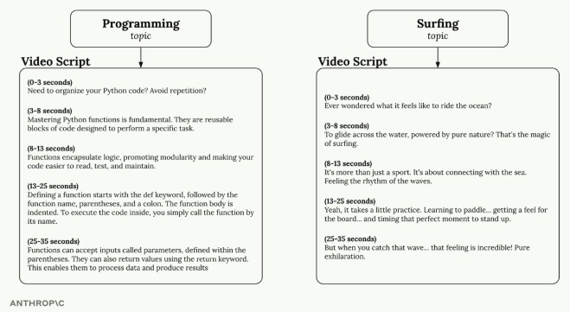
Two very different video scripts generated from two different topics: "Programming" produces an educational script explaining Python functions step by step; "Surfing" produces an entertainment-style script built around excitement and sensory description of riding waves.

Setting Up Content Categories
The first step is defining the different types of content the application might need to generate — genres such as Entertainment (high-energy, culturally relevant, trendy language), Educational (clear, engaging explanations with relatable examples), Comedy (sharp, unexpected content with clever observations and timing), Personal vlog (authentic, intimate, conversational storytelling), Reviews (decisive, experience-based content highlighting strengths and weaknesses), and Storytelling (immersive content using vivid details and emotional connection). Each category gets its own specialized prompt template.
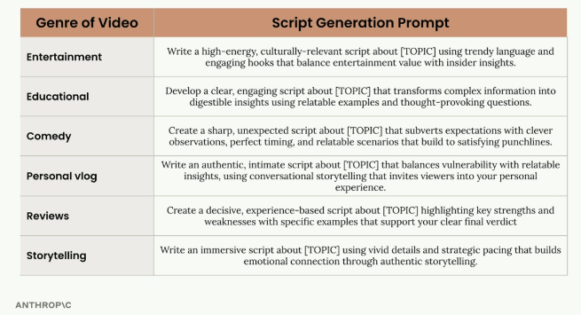
A table mapping each genre (Entertainment, Educational, Comedy, Personal vlog, Reviews, Storytelling) to its own specialized script generation prompt template tuned to that genre's tone and structure.

How Routing Works in Practice
The routing process happens in two steps:
- Categorization — send the user's topic to Claude with a request to categorize it into one of the predefined genres.
- Specialized Processing — use the category result to select the appropriate prompt template and generate content.
For example, if a user enters "Python functions" as their topic, the first step asks Claude to categorize it:
Categorize the topic of a video into one of the listed categories:
<topic>Python functions</topic>

<categories>
- Educational
- Entertainment
- Comedy
- Personal vlog
- Reviews
- Storytelling
</categories>
Claude responds with "Educational", so the educational prompt template is then used to generate the actual script content.
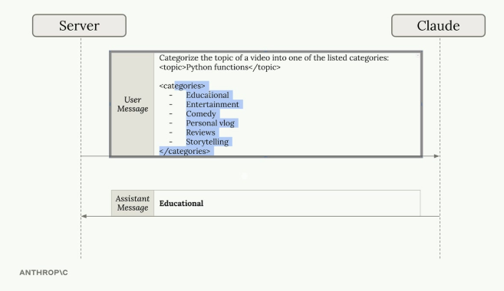
Server sends Claude a user message asking it to categorize the topic "Python functions" into one of the listed categories; Claude's assistant message responds simply with "Educational".

Routing Workflow Architecture
A routing workflow follows this pattern:
- User input goes to a router component first
- The router categorizes the request using an initial Claude call
- Based on the category, the input gets forwarded to one specific processing pipeline
- Each pipeline can have its own workflow, prompts, or tools optimized for that category
The key insight is that user input only goes to one specialized pipeline, not all of them — this allows each pipeline to be highly optimized for its specific use case.
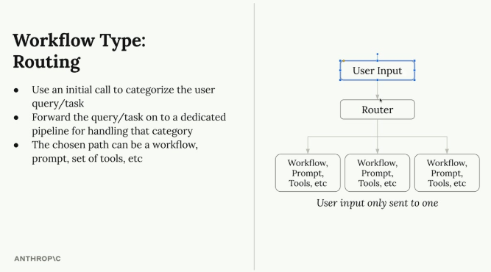
Routing: use an initial call to categorize the user query/task, forward the query/task to a dedicated pipeline for handling that category — the chosen path can be a workflow, prompt, set of tools, etc. Diagram: User Input → Router → one of several dedicated Workflow/Prompt/Tools pipelines, with user input only sent to one.

When to Use Routing
- The application handles diverse types of requests that need different approaches
- Categories that clearly cover the use cases can be defined
- The categorization step can be handled reliably by Claude
- The performance benefit of specialized processing outweighs the overhead of the routing step
This pattern is especially valuable for customer service bots, content generation tools, and any application where the "right" response depends heavily on understanding the type of request being made.

Practice Questions — Lesson 4
Choose the single best answer for each question (A–E).
1. What problem do routing workflows solve?
A) The need to cache repeated prompts
B) Different types of user requests needing different handling approaches, which a one-size-fits-all prompt can't address
C) The inability of Claude to process images
D) The need to run multiple requests in parallel
E) The need to reduce the number of tokens used per request
2. In the video script example, what are the two steps of the routing process?
A) Chaining and aggregation
B) Categorization, then specialized processing using the matching prompt template
C) Parallel requests, then a single merge step
D) Caching, then retrieval
E) Splitting the topic into subtopics, then summarizing each
3. According to the lesson, what does the router send to Claude first?
A) The full final script directly
B) A request to categorize the topic into one of the predefined genres
C) All specialized prompt templates at once
D) A request to translate the topic into another language
E) A request to summarize all previous topics
4. What is the key architectural insight of a routing workflow?
A) User input is sent to all pipelines simultaneously for redundancy
B) User input only goes to one specialized pipeline, not all of them, allowing each to be highly optimized
C) The router itself generates the final content without any pipeline
D) Categories must be discovered dynamically at runtime and cannot be predefined
E) Routing removes the need for any prompt templates
5. According to the lesson, when does routing work well?
A) Only when there is exactly one type of request to handle
B) When the application handles diverse request types, clear categories can be defined, and categorization can be handled reliably by Claude
C) Only for applications that don't use Claude at all
D) Only when no performance overhead is acceptable
E) Only for image-based requests

Lesson 5 — Agents and Tools

Core idea
Agents represent a shift from structured workflows: instead of a rigid predetermined sequence, Claude is given a goal and a reasonably abstract set of tools, and figures out on its own how to combine those tools to achieve the objective — flexible, but with trade-offs in reliability and cost compared to workflows.
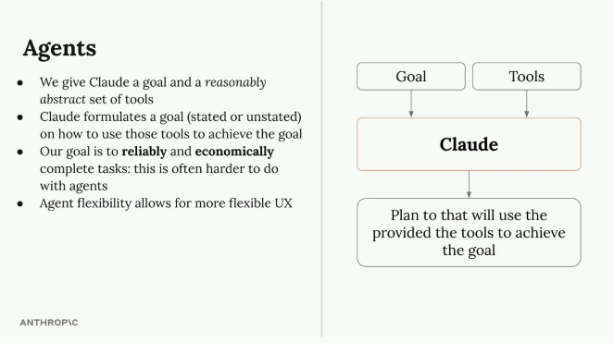
We give Claude a goal and a reasonably abstract set of tools; Claude formulates a plan (stated or unstated) on how to use those tools to achieve the goal; the goal is to reliably and economically complete tasks, which is often harder with agents; agent flexibility allows for more flexible UX. Diagram: Goal + Tools feed into Claude, which produces a plan that will use the provided tools to achieve the goal.

How Tools Make the Agent
The real power of agents lies in combining simple tools in unexpected ways. Consider a basic set of datetime tools: get_current_datetime (gets the current date and time), add_duration_to_datetime (adds time to a given date), and set_reminder (creates a reminder for a specific time).
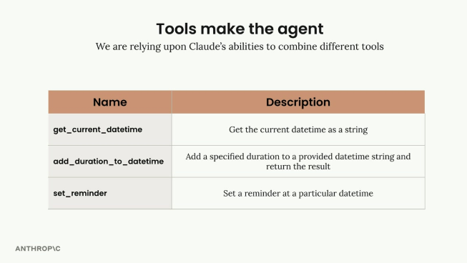
A table listing the 3 tools relied upon: get_current_datetime (get the current datetime as a string), add_duration_to_datetime (add a specified duration to a provided datetime string and return the result), set_reminder (set a reminder at a particular datetime).
These tools seem simple individually, but Claude can chain them together to handle surprisingly complex requests. For "What's the time?", Claude simply calls get_current_datetime. For "What day of the week is it in 11 days?", it chains get_current_datetime followed by add_duration_to_datetime. For setting a gym reminder next Wednesday, it might use all three tools in sequence. Claude can even recognize when it needs more information — if asked "When does my 90-day warranty expire?", it knows to ask when the item was purchased before calculating the expiration date.
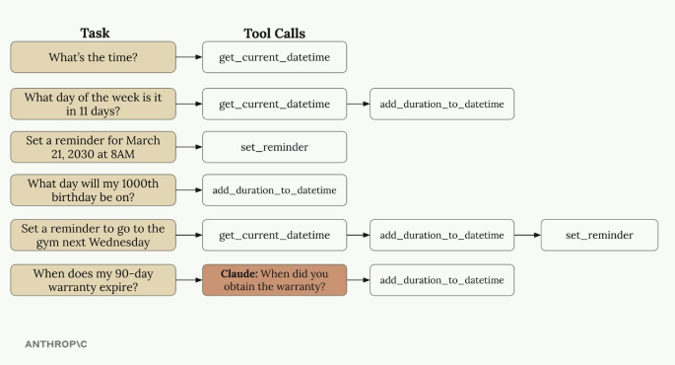
Six example tasks mapped to the tool call chains Claude builds: "What's the time?" → get_current_datetime; "What day of the week is it in 11 days?" → get_current_datetime → add_duration_to_datetime; "Set a reminder for March 21, 2030 at 8AM" → set_reminder; "What day will my 1000th birthday be on?" → add_duration_to_datetime; "Set a reminder to go to the gym next Wednesday" → get_current_datetime → add_duration_to_datetime → set_reminder; "When does my 90-day warranty expire?" → Claude asks "When did you obtain the warranty?" before calling add_duration_to_datetime.

Tools Should Be Abstract
The key insight for building effective agents is providing reasonably abstract tools rather than hyper-specialized ones. Claude Code demonstrates this principle: it has access to generic, flexible tools like bash (run any command), read (read any file), write (create any file), edit (modify files), glob (find files), and grep (search file contents). It notably does not have specialized tools like "refactor code" or "install dependencies" — instead, Claude figures out how to use the basic tools to accomplish these complex tasks. This abstraction lets it handle countless programming scenarios the developers never explicitly planned for.
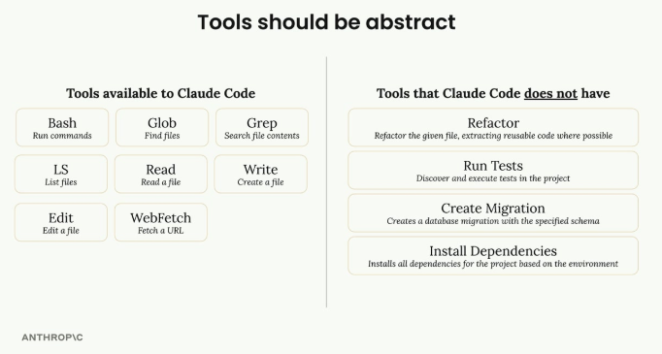
Left column: Tools available to Claude Code — Bash (run commands), Glob (find files), Grep (search file contents), LS (list files), Read (read a file), Write (create a file), Edit (edit a file), WebFetch (fetch a URL). Right column: Tools that Claude Code does NOT have — Refactor, Run Tests, Create Migration, Install Dependencies — these are accomplished by combining the abstract tools instead.

Best Practice: Combinable Tools
When designing agents, provide tools that Claude can combine in creative ways. A social media video agent, for example, might include bash (access to FFMPEG for video processing), generate_image (create images from prompts), text_to_speech (convert text to audio), and post_media (upload content to social platforms).
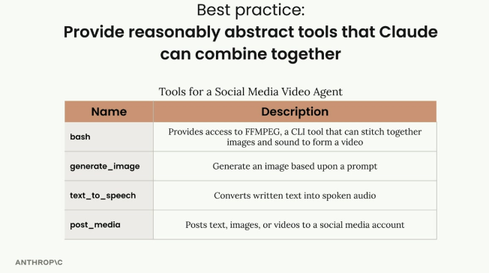
A table listing 4 abstract, combinable tools for a social media video agent: bash (provides access to FFMPEG, a CLI tool that can stitch together images and sound to form a video), generate_image (generate an image based upon a prompt), text_to_speech (converts written text into spoken audio), post_media (posts text, images, or videos to a social media account).
This tool set enables both simple workflows (create and post a video) and more interactive experiences where the agent might generate a sample image first, get user approval, then proceed with video creation. The agent can adapt its approach based on user feedback and preferences — something difficult to achieve with a rigid workflow. This flexibility is what makes agents powerful for building dynamic, user-responsive applications.

Practice Questions — Lesson 5
Choose the single best answer for each question (A–E).
1. What is the key difference between an agent and a workflow, according to the lesson?
A) Agents can only call one tool at a time, workflows can call many
B) A workflow follows a predetermined sequence of steps; an agent is given a goal and a set of tools and figures out the steps itself
C) Agents never use tools, only workflows do
D) Workflows are always faster than agents
E) There is no meaningful difference between the two
2. In the datetime tools example, what does Claude do when asked "When does my 90-day warranty expire?"
A) It refuses to answer without a tool for warranties
B) It recognizes it needs more information and asks when the item was purchased before calculating the expiration date
C) It always assumes the purchase date is today
D) It calls set_reminder immediately without calculating anything
E) It ignores the question and calls get_current_datetime only
3. According to the lesson, what kind of tools does Claude Code have?
A) Hyper-specialized tools like "refactor code" and "install dependencies"
B) Generic, abstract tools like bash, read, write, edit, glob, and grep, which Claude combines to accomplish complex tasks
C) Only a single tool that does everything
D) No tools at all — Claude Code works purely from training knowledge
E) Tools that require the user to manually chain them together
4. Why does the lesson recommend abstract tools over hyper-specialized ones?
A) Abstract tools are always faster to execute
B) Abstract tools can be combined by Claude in creative, unplanned ways to handle scenarios developers never explicitly anticipated
C) Specialized tools are more expensive to define
D) Abstract tools remove the need for a goal
E) Hyper-specialized tools are not supported by the Claude API
5. What best describes the trade-off of using agents instead of workflows, according to the lesson?
A) Agents are always cheaper and more reliable than workflows
B) Agents offer more flexible UX and can adapt to unpredictable tasks, but this flexibility is often harder to make reliable and economical than a workflow
C) Agents cannot be reused across different tasks
D) Agents require no tools, only a goal
E) Workflows are strictly superior in every situation

Lesson 6 — Environment Inspection

Core idea
Claude operates blindly — it needs to be able to observe and understand the results of its own actions to work effectively. Environment inspection is the pattern of making sure Claude can see the outcome of what it just did before deciding what to do next.

Why Environment Inspection Matters
With computer use, every time Claude performs an action like typing text or clicking a button, it immediately receives a screenshot to understand what happened. This isn't just a nice-to-have — it's essential. From Claude's perspective, clicking a button could navigate to a new page, open a menu, or trigger any number of changes. Without being able to see the results, Claude has no way to understand whether its action succeeded or what the new state of the environment looks like.
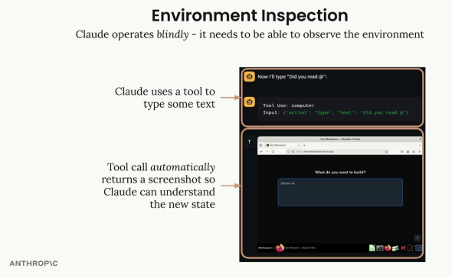
Claude uses a computer tool to type "Did you read @"; the tool call automatically returns a screenshot so Claude can understand the new state of the browser after typing.

Reading Before Writing
This same principle applies to file operations. Before Claude can modify any file, it needs to understand the current contents — a pattern to always follow when building agents. Given a request like "Update the main.py file, add an '/items' route that returns a list of items", Claude first reads the existing code to understand the current structure, and only then makes the requested change without breaking existing functionality.
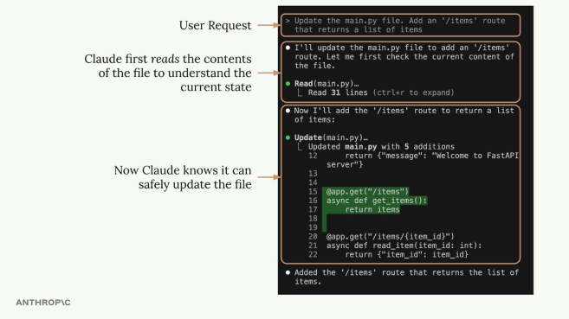
User request asks Claude to add an '/items' route to main.py; Claude first calls Read(main.py) to check the current content before making any change; once it knows the current state, it safely calls Update(main.py) to add the new route, then confirms the route was added.

System Prompts for Environment Inspection
Claude can be guided to inspect its environment through system prompts. For complex tasks like video generation, this becomes especially important. Consider a video creation agent that needs to generate video content using tools like FFmpeg, verify that audio dialogue is placed correctly, and check that visual elements appear as expected. System prompt instructions might include: using the bash tool to run whisper.cpp and generate caption files with timestamps to verify dialogue placement; using FFmpeg to extract screenshots from the video at regular intervals to visually inspect the output; and comparing the generated content against the original requirements.
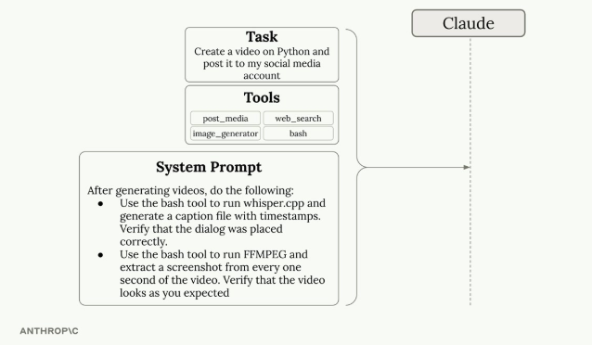
A task ("Create a video on Python and post it to my social media account") with tools (post_media, web_search, image_generator, bash) and a system prompt instructing Claude to, after generating videos: use the bash tool to run whisper.cpp and generate a caption file with timestamps, verifying dialogue placement; and use the bash tool to run FFMPEG and extract a screenshot from every one second of the video, verifying the video looks as expected.

Benefits of Environment Inspection
- Better progress tracking — Claude can gauge how close it is to completing a task.
- Error handling — unexpected results can be detected and corrected.
- Quality assurance — output can be verified before considering a task complete.
- Adaptive behavior — Claude can adjust its approach based on what it observes.

Practice Questions — Lesson 6
Choose the single best answer for each question (A–E).
1. Why does the lesson say Claude "operates blindly"?
A) Claude cannot process images under any circumstances
B) Claude needs to be able to observe and understand the results of its actions to work effectively; without that, it can't know if an action succeeded
C) Claude never needs feedback on its actions
D) Claude always assumes every action fails
E) Claude operates faster without any observation step
2. In computer use, what happens automatically after Claude performs an action like typing or clicking?
A) Nothing, Claude must request a screenshot manually every time
B) The tool call automatically returns a screenshot so Claude can understand the new state
C) The session ends and a new one starts
D) Claude receives a text-only log of the DOM with no visual
E) The action is undone automatically
3. What does "reading before writing" mean in the context of file operations?
A) Claude should write new code first, then check if it worked
B) Before modifying any file, Claude should first read its current contents to understand the existing structure
C) Files should always be deleted before being recreated
D) Claude should read documentation before writing any code, but never read the target file itself
E) Reading and writing must always happen in the same tool call
4. In the video generation example, what does the system prompt instruct Claude to use whisper.cpp for?
A) To generate the video's visual effects
B) To generate a caption file with timestamps, verifying dialogue was placed correctly
C) To post the video to social media
D) To generate the background music
E) To compress the final video file
5. Which of the following is NOT listed as a benefit of environment inspection?
A) Better progress tracking
B) Error handling
C) Quality assurance
D) Adaptive behavior
E) Eliminating the need for any system prompt

Lesson 7 — Workflows vs Agents

Core idea
When building AI-powered applications, you'll often need to choose between two architectural approaches: workflows and agents. Each has distinct advantages and trade-offs suited to different scenarios — the primary goal is to solve problems reliably, and the general recommendation is to favor workflows where possible, resorting to agents only when truly required.

What Are Workflows?
Workflows are a predefined series of calls to Claude designed to solve a known problem or set of problems. Workflows are used when the flow of steps can be pictured ahead of time — essentially when the exact sequence needed to complete a task is known. Workflows break down a big task into much smaller, more specific subtasks, with each step focusing on a single area, which allows Claude to work more precisely.

What Are Agents?
With agents, Claude gets a set of basic tools and is expected to formulate a plan to use these tools to complete a task. Unlike workflows, the exact tasks that will be provided aren't known in advance, so the system needs to be more adaptive. Agents can creatively figure out how to handle a wide variety of challenges by combining tools in unexpected ways.

Benefits and Downsides
Benefits of workflows: Claude can focus on one subtask at a time, generally leading to higher accuracy; far easier to evaluate and test, since each exact step is known; more predictable and reliable execution; better suited for solving specific, well-defined problems.
Benefits of agents: allow for more flexible user experience; far more flexible task completion, since Claude can combine tools in unexpected ways to complete a wide variety of tasks; can handle novel situations that weren't anticipated during development; can ask users for additional input when needed.
Downsides of workflows: far less flexible, dedicated to solving specific types of tasks; generally more constrained user experience, since the exact inputs to the flow need to be known; require more upfront planning and design work.
Downsides of agents: lower successful task completion rate compared to workflows; more challenging to instrument, test, and evaluate, since the series of steps an agent will execute often isn't known in advance; less predictable behavior.
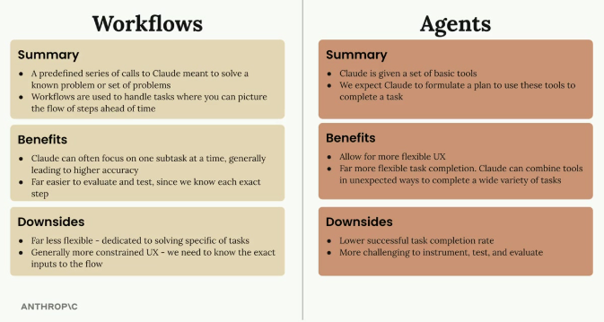
Side-by-side summary comparing Workflows and Agents. Workflows: a predefined series of calls to Claude meant to solve a known problem or set of problems, used when you can picture the flow of steps ahead of time; benefits are focus on one subtask at a time (higher accuracy) and easier to evaluate/test since each exact step is known; downsides are being far less flexible and having a more constrained UX since exact inputs must be known. Agents: Claude is given a set of basic tools and is expected to formulate a plan to use them to complete a task; benefits are more flexible UX and far more flexible task completion by combining tools in unexpected ways; downsides are a lower successful task completion rate and being more challenging to instrument, test, and evaluate.

When to Use Each Approach
The primary goal as an engineer is to solve problems reliably — users don't care that a fancy agent was built, they want a product that works consistently. The general recommendation is to always focus on implementing workflows where possible, and only resort to agents when they are truly required. Workflows provide the reliability and predictability that most production applications need, while agents offer flexibility for scenarios where the exact requirements can't be predetermined. Workflows fit well-defined processes; agents fit unpredictable, varied user requests that require creative problem-solving.

Practice Questions — Lesson 7
Choose the single best answer for each question (A–E).
1. According to the lesson, what is the general recommendation when choosing between workflows and agents?
A) Always use agents, since they are more flexible
B) Always focus on implementing workflows where possible, and only resort to agents when truly required
C) Always mix both approaches within the same request
D) Avoid workflows entirely since they are less flexible
E) The choice makes no difference to reliability
2. Which of the following is listed as a benefit of workflows, not agents?
A) Can handle novel situations that weren't anticipated during development
B) Far easier to evaluate and test, since each exact step is known
C) Far more flexible task completion by combining tools in unexpected ways
D) Allows for a more flexible user experience
E) Can ask users for additional input when needed
3. Which of the following is listed as a downside of agents, not workflows?
A) Far less flexible, dedicated to solving specific types of tasks
B) Requires more upfront planning and design work
C) Lower successful task completion rate compared to workflows
D) More constrained user experience, since exact inputs must be known
E) Higher accuracy on individual subtasks
4. Why does the lesson say users "probably don't care" whether an agent was used?
A) Because agents are always invisible to users
B) Because the engineer's primary goal is to solve problems reliably, and users want a product that works consistently, not a fancy architecture
C) Because agents are cheaper than workflows in every case
D) Because users always prefer agents over workflows
E) Because workflows cannot be used in production
5. According to the lesson, when should agents be favored over workflows?
A) When the exact sequence of steps can be pictured ahead of time
B) When handling unpredictable, varied user requests that require creative problem-solving and the exact requirements can't be predetermined
C) When the highest possible task completion rate is required
D) When testing and evaluation must be as simple as possible
E) Agents should always be favored regardless of the situation

